PSIRF planning – Pressure ulcer example scenario

Contents
Introduction 2
Developing the patient safety incident response plan 3
1) Understand capacity 3
2) Map services 3
3) Plan responses 3
Examine patient safety incident records and data 3
Describe safety issues demonstrated by the data 3
Identify improvement work underway 4
Agree response methods 4
Completing the patient safety incident response plan template 6
A living and responsive plan 7

This guidance has been developed collaboratively between Stop the Pressure Programme, National Wound Care Strategy leads and members of the Patient Safety Team, with the support from the Patient Safety Incident Response Framework (PSIRF) Implementation and Working Groups.

Introduction
The Patient safety incident response framework (PSIRF) represents a new approach to responding to incidents. Under PSIRF, those leading the patient safety agenda within provider organisations, together with internal and external stakeholders (including patient safety partners, commissioners, NHS England, regulators, Local Healthwatch, coroners etc), decide how to respond to patient safety incidents based on the need to generate insight to inform safety improvement where it matters most. Key issues must first be identified and described as part of planning activities before an organisation agrees how it intends to respond to maximise learning and improvement.
PSIRF planning is captured by the cycle illustrated below. More information is provided in the Guide to responding proportionately to patient safety incident as well as in the patient safety incident response plan template.
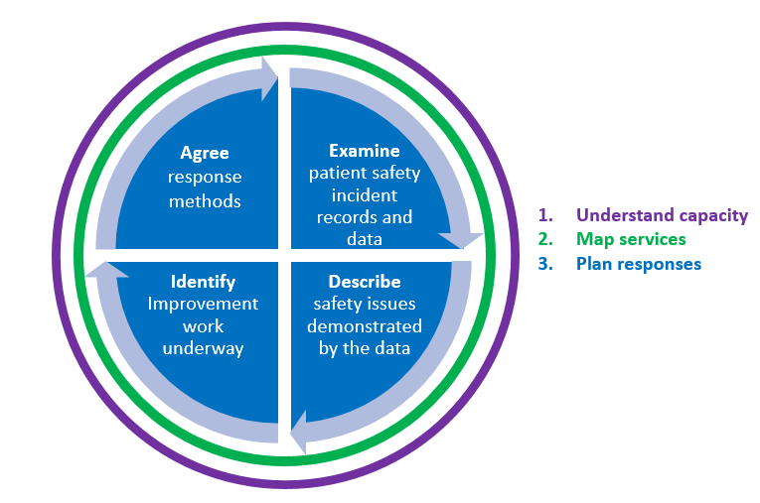
The example scenario below is a hypothetical one; created to illustrate how an organisation might work through the PSIRF planning cycle in relation to a specific incident type. We have chosen pressure ulcers because they have been associated with specific review and investigation processes under the existing (Serious Incident, SI) process.
Note:
PSIRF does not change:
- Any reporting requirements or expectations to record patient safety events.
- The need to engage those affected by patient safety incidents (including patients, families, and staff) and to uphold the Duty of Candour. See PSIRF supporting guidance B1465-2.-Engaging-and-involving...-v1-FINAL.pdf (england.nhs.uk) for further information.
Patient safety incident data cannot measure prevalence or incidence of pressure ulcers other data sources are required for this purpose. The National Wound Care Strategy Programme is currently developing recommendations for reporting of pressure ulcers.

Developing the patient safety incident response plan
Note: this example focuses on step three of the PSIRF planning cycle: Planning responses.
- Understand capacity
Let’s imagine the PSIRF lead, with their supporting team for United Holby Trust and representatives from relevant internal and external stakeholder groups, has already done the first bit that is needed in any planning process. That is, they understand the type and estimated quantity of responses the organisation should be able to support based on current and/or planned capacity and capability.
- Map services
In this phase the PSIRF team undertook a mapping exercise to understand what services the organisation offers and who needs to be engaged in response planning

Plan responses
The PSIRF team now moved on to plan responses, which includes four activities: examine, describe, identify and agree.
Note: the distinction between the four ‘activities’ is not always well defined; planning responses will involve going around the cycle (as well as back and forth between activities) multiple times.

Examine patient safety incident records and data
The ‘examine’ phase includes identifying information sources and starting to gather and extract information about an organisation’s patient safety incident profile (ie what are the incidents and issues affecting patient safety across the organisation?).
As part of their work, the PSIRF lead and supporting team at United Holby Trust note that pressure ulcers (PUs) were one of the most recorded incidents, according to past three years of data from their Local risk management system (LRMS), and were associated with many complaints from patients, families, and carers. This finding is shared and discussed with the representatives from relevant internal and external stakeholder groups who agree it should be considered further. Clinical staff also fed back that they were concerned that the actions following RCAs focused on quick fixes (eg staff reminders) rather than addressing the underlying systemic contributory factors.
The PSIRF lead and supporting team, with support from representatives from relevant internal and external stakeholder groups, decided to explore this further to determine the best way to respond to PUs under PSIRF to maximise learning and improvement

Describe safety issues demonstrated by the data
The PSIRF team engaged with the Tissue Viability Service and Matrons, and a smaller focus group (including members from both internal and external stakeholder groups) to look through patient safety incident recording and complaints data in detail. Together they were able to triangulate this with information from a national surveillance and local surveillance audit which looks at the prevalence of PUs and adherence to the aSSKINg (assess risk; skin assessment and skin care; surface; keep moving; incontinence and moisture; nutrition and hydration; and giving information or getting help) care bundle.
Let’s imagine their discussions highlighted the following safety issues:
- United Holby Trust has a high prevalence of PUs (22%) compared to national average (8%) – data shows this has been steadily increasing over the last three years.
- Compliance with documentation of repositioning is below their own organisational standard
- Although high specification equipment is used patients are still getting pressure ulcers
- More severe (category 3 and 4) pressure ulcers are more common in patients with darker skin than those with lighter skin. To a large extent, this has contributed to the higher-than-average prevalence. As these are the most severe category of pressure ulcer this is of particular concern.

Identify improvement work underway
Working with the Tissue Viability Service the PSIRF team, with support from members of the small focus group, seek to identify any relevant improvement work underway to address the key issues described. The only programme currently in place is focussed on numeration, that is, each ward identifying:
- Number of pressure ulcers
- Grade of each pressure ulcer
- Whether the pressure ulcer had developed during hospital admission, and
- Weekly audit of documentation (focused on how well preventative care for pressure ulcer documentation is completed)
These activities are undertaken by the Tissue Viability Service and/or Matrons. There is no specific work to address the issues identified from this work.

Agree response methods
Based on the above discussions, and consideration of Tissue Viability Service and Patient safety Incident response team capacity, the PSIRF lead, working with the PSIRF support team and small focus group, propose the following response methods. This is shared with relevant representatives from internal and external stakeholder groups at a collective patient safety incident response planning discussion meeting.
- Walkthrough analysis to understand use of repositioning documentation
- Observations to inform understanding of contextual factors influencing equipment selection and use
- Observations in peer organisation Royal City Hospital which has reported low prevalence of pressure damage across their patient population and has a similar ethnic mix
- Information about pressure ulcers through regular reporting systems will continue to be monitored to look for any changes/emerging risks/issues – the patient safety incident response plan will be reviewed accordingly
During the meeting there is broad agreement for this approach. It is also agreed that response methods 1-3 will be led by the Tissue Viability Service lead with support from the patient safety specialist who has been trained in relevant approaches.
Note: the scope of each activity (i.e. number of cases and/or number of days the work will be undertaken for) will need to be considered by relevant representatives from internal and external stakeholder groups and agreed by the PSIRF lead and those supporting the response. This can be reviewed as work progresses and changed if it is felt more or less activity is needed to generate the insight required to inform improvement.
Weekly check of documentation will stop to free up time within the Tissue Viability Service. Instead, the Tissue Viability Service, with support from relevant colleagues within the Quality Improvement and Patient Safety team (who have relevant experience/skills), will work with the data analysis team to determine how reports can be automatically generated to deliver the relevant information from point of care documentation and feed this back to individual areas via the Trust dashboard system.
All PUs recorded on the LRMS will be read/screened by the matrons (or equivalent clinical/department lead) to determine:
- appropriate level of engagement with everyone affected by a PU
- requirements of Duty of Candour are fulfilled wherever required
- if any other referrals need to be made (eg safeguarding etc)
- if an individual learning response is needed (as described/outlined by the patient safety incident response plan) Note: Given the agreed response methods, it is expected that most PUs will not require an individual learning response except in cases where there is potential for new insight in relation to a new/emerging area of risk.

Completing the patient safety incident response plan template
There are different ways of populating the table in the patient safety incident response template. We have used a single row to describe responses to pressure ulcers in general. The narrative within the patient safety incident response policy or plan should clearly describe how incidents will be screened to ensure they are managed appropriately according to the agreed and/or required response methods.

Patient safety incident type or issue | Planned response | Anticipated improvement route
Pressure ulcers: | - Screening to inform response decision and engagement  - Walkthrough analysis to understand use of repositioning documentation  - Observations to inform understanding of contextual factors influencing equipment selection and use  - Observations in peer organisation Royal City Hospital who have reported low prevalence of pressure damage in patients with darker skin  - Continued monitoring of patient safety incident records to determine any emerging risks/issues | Build case for improvement plan

Note: the full draft Patient safety incident response plan must be considered and agreed by relevant representatives from internal and external stakeholder groups before being approved by the trust board. The relevant lead within the Integrated Care Board – who must have been involved in the development of the plan – will sign off the documentation and work with the PSIRF lead (and other board members as required) to agreed a transition date. Final documentation must be published on the provider organisations website. Further details to support curation and agreement of the patient safety incident response policy and plan are available: B1465-6.-PSIRF-Prep-Guide-v1-FINAL.pdf (england.nhs.uk)

A living and responsive plan
Six months after publishing their patient safety incident response plan, the Tissue Viability Service (via continued monitoring of patient safety incident records) notice an increase in patients being admitted with PU.
The Tissue Viability Service notifies the patient safety team and PSIRF lead to enable exploration of this with the relevant ICB lead (for patient safety) and other members of the small focus group that supported data analysis during the development of the patient safety incident response plan.
The ICB lead undertakes analysis of data which shows increase in PU prevalence and incidents recorded by community/district nursing team particularly in the Great Valley region.
This is discussed between the PSIRF, ICB lead and members of the small focus group. At this stage it is agreed that United Holby Trust will continue without any changes to their patient safety incident response plan and that the ICB will explore the issue.
The ICB lead agrees to facilitate a multi-disciplinary team review to explore the issues in more detail. This will include a review of data including:
- Quality outcomes data (extracted from a local system by local analysts)
- NHS benchmarking data (including staffing/staff vacancies)
- Demand/ referral rate to adult community provider
Findings will be considered by a safety action development group (which include both internal and external stakeholders), coordinated and facilitated by the ICB lead. Guidance outlined in the safety action development guide will inform the development of any safety actions.

The appointment of a PSIRF lead and supporting team should be completed as part of PSIRF orientation which is described in the PSIRF preparation guide
This timeframe is recommended within the Guide for responding proportionately to patient safety incidents
Using the 'aSSKINg' model in pressure ulcer prevention and care planning - PubMed (nih.gov)

